How Can I Help?

We Need Your Help! There are many opportunities for you to serve in this ministry. All we ask is that you have a willing heart and a spirit of obedience, and you can play a crucial role in God's ministry of Changing Hearts, Transforming Lives and Impacting the World. Here's some basic information to help you "get involved."
Join the Hutchins Unit Weekend Team: Kairos volunteers come from all walks and strata of life. They all share a desire to follow Christ's admonition of Matthew 25:36, "I was in prison, and you visited me." If you feel God's call to minister to the incarcerated, apply for an upcoming Kairos weekend.
- our website https://Kairos-Hutchins-Unit.org
- our email (Admin@Kairos-Hutchins-Unit.org).
Attend a Closing Ceremony: Many team members have first attended a closing ceremony. The closing ceremony takes place on the Sunday afternoon of the weekend Kairos from 2:30 -5:00 PM in the Hutchins Unit chapel. To attend a closing ceremony, you must complete and submit an application form before the deadline posted on the form.
Be a Prayer Partner: All Kairos activities are covered with prayer. You can be a part of that prayer effort. As a physical symbol of your prayer, we have prayer links that are pieces of brightly colored paper with each person’s name & home city. These links are joined to form a long chain that extends around the room where Kairos is held at the prison.
Be a “Support Volunteer”: Each Kairos retreat weekend has opportunities for outside support, such as providing cookies, writing letters of support, or preparing meals. Get your church's Sunday school classes to color placemats for mealtime in prison.
Be a Ministry Financial Donor: All Kairos activities are funded by donations. Hutchins Kairos is a 100% volunteer organization and part of Kairos Prison Ministry International, Inc. a 501(C)(3) not-for-profit corporation chartered in the State of Florida. You will be provided a receipt for your tax-deductible donation. See Donations for details.
Be a Cookie Provider: We may need more than 500 dozen cookies for a typical Kairos Weekend. Do the math... that's 6,000 cookies! Every inmate & staff member at Memorial gets at least a dozen cookies. Kairos cookies are a tangible expression of Christian love and an indication of God's concern for a group of people who seldom encounter either in the course of their daily lives. Your loving sacrifice will provide "bread" that shines the Light of God's Grace into the darkest corners of a prison unit. May God bless you for the gift! Contact us for detailed instructions for types of cookies & the special way these are prepared.

Sound interesting? Contact us today to learn more about this opportunity to serve.
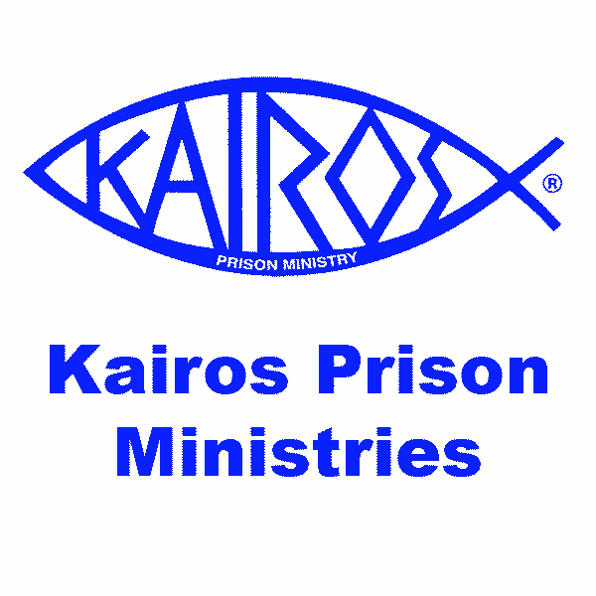
Website at https://Kairos-Hutchins-Unit.org
Email at admin@Kairos-Hutchins-Unit.org.
Mailing address:
Kairos of Texas-Hutchins
PO BOX 863883
Plano Texas 75086

